ISTE-230 Introduction to Database & Data Modeling

Practice Exercise 1
Name: Brian Zarzuela

Part 1
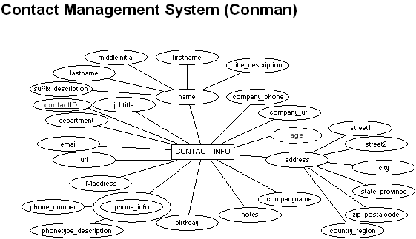
For the table below, please classify each attribute specified based on the E-R diagram above, which uses the Chen notation covered in Week 1. Please place the best answer for each column that best describes the attribute.
Attribute | Composite or Simple | Single-valued or Multi-valued | Stored or Derived | Identifier ? (Yes or no)
name | Composite | Single-valued | Stored | No
age | Simple | Single-valued | Derived | No
city | Simple | Single-valued | Stored | No
contactID | Simple | Single-valued | Stored | Yes
phone_info | Composite | Multi-valued | Stored | No

Part 2
Using relational structure notation, please transpose the E-R diagram below.
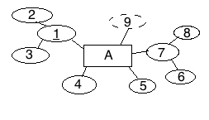
Your Answer: A (2, 3, 4, 5, 6, 8)

Part 3
For each relation below, state whether or not the relation is in 1NF. If the relation is not in 1NF, please list the characteristic(s) being violated.
A (1, 2, 3, 4, 5, 6, 6, 7)
Your Answer: Not 1NF because each attribute name is not unique
B (1, 2, 3, 4)
Your Answer: Not 1NF because no primary key exists
C (1, 2, 3, 4, 5, 6, 7, 8)
Your Answer: Is 1NF

